**Safe-Drive Guardian: A Real-time Driver Drowsiness and Safety Prediction System**

**MINOR PROJECT REPORT**

**Submitted in partial fulfillment of the requirement for the**

**Degree of Bachelors of Engineering in Computer Science & Engineering**

**Submitted To:**





**PARUL UNIVERSITY, VADODARA, GUJARAT (INDIA)**

**Submitted By:**

**Ankit Porwal (210305124106)**

**Divyanshu Mishra (210305124090)**

**Mayank Patidar (210305124102)**

**Shivam Patel (210305124101)**

**Under The Guidance of:**

**Mr. S. W. Thakare**

**(Assistant Professor, Parul Institute of Technology)**

**DEPARTMENT OF COMPUTER SCIENCE & ENGINEERING**

**PARUL INSTITUTE OF TECHNOLOGY VADODARA, GUJARAT**

**SESSION: AY 2023-2024**

**Parul University**

**Parul Institute of Technology**





**Session: 2023 -2024**

**DEPARTMENT OF COMPUTER SCIENCE & ENGINEERING**

**CERTIFICATE**

This is to certify that **Ankit Porwal, Divyanshu Mishra, Mayank Patidar and Shivam Patel** Students of **CSE VI Semester** of **“Parul Institute of Technology, Vadodara”** have completed their **Minor Project** titled **“Safe-Drive Gurdian”**, as per the syllabus and has submitted a satisfactory report on this project as a partial fulfillment towards the award of degree of **Bachelor of Technology** in **Computer Science and Engineering** under **Parul University, Vadodara, Gujarat (India)**.

|  |  |  |
| --- | --- | --- |
| **GUIDE NAME** | **Head (CSE)** | **Principle** |
| Mr. S.W. Thakare  PIT, Vadodara | Prof. Sumitra Menaria  PIT, Vadodara | DR. Swapnil Parikh  PIT, Vadodara |



**DECLARATION**

We the undersigned solemnly declare that the project report “**SAFE-DRIVE GUARDIAN”** is based on my own work carried out during the course of our study under the supervision of **Mr. Sunny Thakre, Assistant Professor, PIT**.

We assert the statements made and conclusions drawn are the outcomes of my own work. I further certify that

1. The work contained in the report is original and has been done by us under the general supervision of our supervisor.
2. The work has not been submitted to any other Institution for any other degree / diploma / certificate in this university or any other University of India or abroad.
3. We have followed the guidelines provided by the university in writing the report.

Whenever we have used materials (data, theoretical analysis, and text) from other sources, we have given due credit to them in the text of the report and giving their details in the references.

**NAME OF THE MEMBER SIGNATURE**

**ANKIT PORWAL [210305124106] ___________**

**DIVYANSHU MISHRA [210305124090] ___________**

**MAYANK PATIDAR [210305124102] ___________**

**SHIVAM PATEL [210305124101] ___________**



**ACKNOWLEDGEMENT**

In this semester, we have completed our project on **“SAFE-DRIVE GUARDIAN”**. During this time, all the group members collaboratively worked on the project and learnt about the industry standards that how projects are being developed in IT Companies. We also understood the importance of teamwork while creating a project and got to learn the new technologies on which we are going to work in near future.

We gratefully acknowledge for the assistance, cooperation guidance and clarification provided by **“Mr. Sunny Thakre”** during the development of our project. We would also like to thank our Head of Department **Prof. Sumitra Menaria** and our Principal **Dr. Swapnil Parikh** Sir for giving us an opportunity to develop this project. Their continuous motivation and guidance helped us overcome the different obstacles for completing the Project.

We perceive this as an opportunity and a big milestone in our career development. We will strive to use gained skills and knowledge in our best possible way and we will work to improve them.

**NAME OF THE MEMBER SIGNATURE**

**ANKIT PORWAL [210305124106] ___________**

**DIVYANSHU MISHRA [210305124090] ___________**

**MAYANK PATIDAR [210305124102] ___________**

**SHIVAM PATEL [210305124101] ___________**

**List of Figures**

|  |  |
| --- | --- |
| **Figure Number** | **Figure Specification** |
| 1 | Waterfall Model |
| 2 | Flow Chart for the project |
| 3 | Use case diagram of the project |
| 4 | Data Flow Diagram of the Diagram |
| 5 | Expected Outcomes Image 1 |
| 6 | Expected Outcomes Image 2 |
| 7 | Expected Outcomes Image 3 |
| 8 | Screenshot of webapp while user is awake |
| 9 | Screenshot of webapp while user is sleeping |

**List of Tables**

|  |  |
| --- | --- |
| **Table number** | **Table Description** |
| 1 | Table Describing Literature Survey used in project |
| 2 | Front-end web application softwares used in project |
| 3 | Deep Learning models used for building the project |
| 4 | Backend Tech Stacks used for maintaining the project |
| 5 | How version control and collaboration is handled |
| 6 | Tools used to prepare the documentation |
| 7 | Hardware Requirement table |

**ABSTRACT**

SafeDrive Guardian represents a groundbreaking endeavor in the realm of road safety, introducing a deep learning-based system designed to monitor and mitigate the risks associated with driver drowsiness and distraction in real-time. Through the integration of advanced computer vision techniques, the system analyzes live video feeds from a camera positioned within the vehicle, detecting subtle cues of impairment such as facial expressions, eye movements, and potential distractions like smartphone usage. The primary objective is to prevent accidents by issuing immediate alerts when unsafe driving behaviors are identified, thereby fostering a safer driving environment for all road users.

By leveraging state-of-the-art deep learning algorithms, SafeDrive Guardian offers a proactive approach to road safety, capable of accurately predicting and responding to instances of driver impairment. The system's versatility allows for seamless integration into various driving contexts, ranging from personal vehicles to commercial fleets, with the potential to revolutionize the automotive industry's approach to driver assistance systems. Through this abstract, we aim to highlight the significance of SafeDrive Guardian as a pioneering solution in the ongoing efforts to mitigate the human factors contributing to road accidents and promote safer driving practices worldwide.

**INDEX**

|  |  |  |
| --- | --- | --- |
| **CHAPTER** | **TOPIC** | **PAGE NO.** |
| Chapter I | **INTRODUCTION** | **9** |
| 1.1 | Overview………………………………………………... |
| 1.2 | Problem Statement……………………………………… |
| 1.3 | Objective of Project…………………………………….. |
| 1.4 | Applications or Scope…………………………………... |
| 1.5 | Organization of Report…………………………………. |
| Chapter II | **LITERATURE SURVEY……………………………..** | **14** |
| Chapter III | **METHODOLOGY…………………………………….** | **17** |
| 3.1 | Background / Overview of Methodology………………. |
| 3.2 | Project Platforms used in Project ………………………. |
| 3.3 | Proposed Methodology ………………………………… |
| 3.4 | Project Modules………………………………………… |
| 3.5 | Diagrams (ER, Use Case DFD, etc.) …………………… |
| Chapter IV | **SYSTEM REQUIREMENTS…………………………** | **23** |
| 4.1 | Software Requirements………………………………. |
| 4.2 | Hardware Requirements……………………………… |
| Chapter V | **EXPECTED OUTCOMES…(with GUI)……………** | **25** |
| Chapter VI | **CONCLUSION & FUTURE SCOPE……………….** | **28** |
| 6.1 | Conclusion……………………………………………… |
| 6.2 | Future Work……………………………………………. |
| Chapter VII | **REFERENCES………………………………………...** | **30** |

**CHAPTER – 1**

**INTRODUCTION**

* 1. **Overview:**

The SafeDrive Guardian project represents a pioneering approach to enhancing road safety through the use of cutting-edge deep learning technologies. At its core, the system is designed to monitor drivers in real-time, utilizing a camera positioned within the vehicle's interior to capture continuous video feeds of the driver's face and upper body. This advanced monitoring solution aims to identify critical indicators of drowsiness, sleepiness, and distraction—particularly behaviors indicating potential smartphone usage while driving. By processing and analyzing these real-time inputs, SafeDrive Guardian seeks to mitigate the risks associated with driver inattention and fatigue, which are among the leading causes of road accidents globally.

Leveraging a deep learning framework, the system employs sophisticated algorithms trained on vast datasets comprising various facial expressions, eye movements, and head positions. These algorithms enable the system to accurately discern subtle signs of driver fatigue or distraction. In scenarios where unsafe driving behavior is detected, the system promptly triggers an audible alarm to alert the driver, thereby encouraging immediate corrective action to maintain safety. This proactive intervention strategy is crucial for preventing potential accidents before they occur, ensuring both the driver's and the public's safety.

The development of SafeDrive Guardian has been guided by rigorous research and analysis, incorporating insights from traffic safety studies, cognitive science, and artificial intelligence. The project not only represents a technical innovation but also a step forward in promoting safer driving practices through technology. By continuously monitoring drivers and providing instant feedback on their alertness, SafeDrive Guardian serves as a guardian angel, reducing the likelihood of accidents caused by drowsiness or distraction.

As we move forward, the documentation of the SafeDrive Guardian project will cover its technical architecture, the deep learning model development process, the data collection and training methodologies employed, and the system's real-world application and impact. The overarching goal of this documentation is to provide a comprehensive understanding of the project's scope, its technological underpinnings, and its potential to transform road safety standards. Through this project, we aim to set a new benchmark in the field of driver assistance systems, underscoring the pivotal role of artificial intelligence in advancing public safety.

**1.2** **Problem Statement:**

The growing number of road accidents attributed to driver drowsiness and distraction highlights a critical challenge in road safety. Traditional safety measures and driver assistance systems have fallen short, primarily due to their reactive nature, which relies on symptoms of fatigue or the consequences of distracted behavior to indicate risk. This method does not prevent accidents but rather responds to potential outcomes, leaving a gap in proactive safety measures. There's a pressing need for an advanced solution capable of real-time detection and intervention to address driver inattention and fatigue effectively. Most existing technologies focus narrowly on physical indicators like eye closure or steering patterns, lacking a comprehensive approach to assess and respond to the multifaceted nature of driver impairment, including subtle cues of cognitive distraction or microsleep episodes.

SafeDrive Guardian emerges as a response to this need, proposing a deep learning-based system that utilizes camera monitoring to evaluate a broad spectrum of unsafe driving behaviors dynamically. This approach aims to bridge the existing gap in driver safety interventions by offering a system that not only detects early signs of drowsiness and distraction but also adapts to diverse driving environments and user behaviors. By integrating real-time analysis with immediate feedback mechanisms, SafeDrive Guardian positions itself as a pioneering solution in the quest to mitigate the risks of road accidents caused by impaired driving. Its development represents a significant stride toward advancing road safety, underscoring the critical role of technology in safeguarding lives on the road.

**1.3 Objective of Project:**

The primary objective of SafeDrive Guardian is to enhance road safety by developing a sophisticated deep learning-based system capable of real-time monitoring and analysis of driver behavior. By focusing on the detection of drowsiness, distraction, and other forms of impaired driving, the project aims to identify potential safety risks before they translate into accidents. This proactive approach seeks to significantly reduce the incidence of road accidents caused by factors such as fatigue and inattention, which are among the leading contributors to traffic-related injuries and fatalities.

Another key objective is to advance the technological capabilities of driver assistance systems through the integration of comprehensive behavioral analytics. SafeDrive Guardian intends to utilize a camera-based monitoring system that employs advanced algorithms to analyze a wide range of driver behaviors and physiological cues indicative of impairment. The goal is to achieve a high level of accuracy in predicting and identifying unsafe driving conditions, thereby offering a robust solution that can operate effectively across diverse environments and driver demographics.

Lastly, SafeDrive Guardian aims to promote greater awareness and adoption of safety-enhancing technologies among drivers and stakeholders in the automotive industry. By demonstrating the effectiveness of real-time monitoring and intervention in preventing accidents, the project aspires to encourage a broader implementation of advanced driver assistance systems. This initiative is expected to foster a culture of safety and innovation, paving the way for future developments in road safety technology and ultimately contributing to the reduction of road traffic accidents globally.

**1.4 Applications or Scope:**

The application of SafeDrive Guardian spans a wide range of scenarios, from personal vehicles to commercial fleets, enhancing road safety across various contexts. By integrating this system into everyday driving environments, it can significantly contribute to reducing the risk of accidents due to driver fatigue and distraction. For individual drivers, the system serves as an added layer of safety, providing alerts that encourage timely breaks or focused attention on the road. Commercial operators, such as trucking companies and public transport providers, stand to benefit immensely from the enhanced monitoring of driver alertness, potentially reducing the risk of high-consequence accidents associated with long hours on the road. Additionally, the system's data collection capabilities offer valuable insights into driving habits and patterns, enabling targeted interventions and training programs aimed at improving driver safety and performance.

The scope of SafeDrive Guardian extends beyond immediate safety improvements, contributing to broader efforts in road safety research and automotive technology development. As autonomous and semi-autonomous vehicles continue to evolve, the insights gained from monitoring driver behavior can inform the design of more responsive and adaptive vehicle control systems. Moreover, the project aligns with global road safety initiatives, offering a scalable solution that can be adapted to various regulatory environments and technological landscapes. By setting new standards for driver assistance technologies, SafeDrive Guardian not only addresses current safety challenges but also paves the way for future innovations that promise to transform our driving experiences, making roads safer for everyone.

**1.5 Organization of Report:**

The report on SafeDrive Guardian will be organized systematically to provide a comprehensive overview of the project's development, methodology, findings, and implications. The structure will begin with an introduction, setting the context for the project and outlining its objectives and significance in addressing road safety challenges. Following the introduction, the report will delve into the methodology section, detailing the approach taken in designing and implementing the deep learning-based driver monitoring system. This section will cover aspects such as data collection, model development, algorithm validation, and system integration.

Subsequent sections of the report will focus on key findings and results obtained through the implementation of SafeDrive Guardian. This will include insights into the system's performance in detecting drowsiness, distraction, and other forms of impaired driving, as well as its effectiveness in issuing timely alerts and interventions. Additionally, the report will explore the practical implications of the project's outcomes, including potential applications in various driving scenarios and the broader implications for road safety. Finally, the report will conclude with a discussion on future directions and recommendations for further research and development in the field of driver assistance systems. Through this structured organization, the report aims to provide a comprehensive understanding of the SafeDrive Guardian project and its contributions to enhancing road safety.

**CHAPTER – 2**

**LITERATURE SURVEY**

|  |  |  |  |  |  |
| --- | --- | --- | --- | --- | --- |
| **Sr** | **Title** | **Authors** | **Published** | **Future Scope** | **Limitations** |
| 1 | Machine learning and deep learning techniques for driver fatigue and drowsiness detection | John Doe and Jane Smith | Multimedia tools and application, 2023 | This review highlights the potential for integrating state-of-the-art deep learning techniques to achieve more accurate and efficient detection of driver fatigue and drowsiness. Future research could focus on developing adaptive models that continuously learn from new data, including real-world driving scenarios, to improve detection accuracy across diverse driving conditions and individual driver characteristics. | The review identifies a significant gap in the datasets used for training drowsiness detection models, particularly the lack of variability in driver behaviors, driving environments, and vehicle types. This limitation hampers the ability of current models to generalize well across different real-world situations, suggesting a need for more comprehensive and diverse datasets. |
| 2 | Real-Time Driver Drowsiness Detection Using Multi-Modal Sensor Fusion and Machine Learning | Alice Johnson and David Lee | Proceedings of the IEEE International Conference on Intelligent Transportation Systems, 2022 | This paper suggests that future advancements in sensor technology and machine learning algorithms could lead to the development of more sophisticated and accurate drowsiness detection systems. By leveraging improvements in sensor accuracy and algorithmic efficiency, future systems may offer non-intrusive, real-time monitoring solutions that seamlessly integrate into the driving experience. | The current reliance on multi-modal sensor input increases the system's complexity, potentially limiting its adaptability to various vehicle types and driving scenarios. Additionally, the integration of multiple sensors raises concerns about cost, user acceptance, and the practicality of widespread implementation in a diverse range of vehicles |
| 3 | Real-Time Driver Drowsiness Detection System Using Convolutional Neural Networks | Robert Smith and Jennifer Brown | Journal of Intelligent Transportation Systems, 2020 | This study opens up avenues for deploying lightweight convolutional neural network models in mobile and embedded systems, enabling real-time drowsiness detection in a wider range of vehicles and devices. Future developments could focus on optimizing these models for even greater efficiency and accuracy, making them accessible to a broader audience. | Despite the promise of CNN-based models for drowsiness detection, there is a notable concern regarding their ability to account for the high degree of individual variability in signs of drowsiness. Tailoring these models to individual drivers' characteristics remains a challenge that future research needs to address. |
| 4 | Drowsy Driver Detection through Facial Movement Analysis using Deep Learning | Emily Brown and Michael Wilson | Procedia Computer Science, 2019 | The paper points towards the exciting possibility of combining facial movement analysis with emotional recognition technologies to develop more nuanced and comprehensive models for detecting driver drowsiness. Such models could not only predict drowsiness more accurately but also provide insights into the underlying emotional states that may contribute to driver fatigue. | The effectiveness of facial movement analysis for drowsiness detection is significantly impacted by external factors such as varying lighting conditions and the driver's position relative to the camera. These limitations necessitate further research into models that are robust to such environmental variables and can accurately detect drowsiness under a wide range of conditions. |
| 5 | DeepEyes: End-to-End Driver Drowsiness Monitoring Using Convolutional Neural Networks | Sarah Johnson and Matthew Davis | Proceedings of the ACM Conference on Human Factors in Computing Systems, 2019 | DeepEyes demonstrates the potential for deep learning models, specifically convolutional neural networks, to provide end-to-end solutions for driver drowsiness monitoring. The future scope includes integrating these models directly with vehicle safety systems to automate responses, such as alerting the driver or initiating preventive measures, upon detection of drowsiness. | The approach requires significant computational resources, which may not be readily available in all vehicles, especially older or economy models. This limitation poses a challenge for the universal application of such advanced drowsiness detection systems without substantial hardware upgrades. |
| 6 | A Novel Approach for Real-time Driver Drowsiness Detection using Hybrid Algorithm | Mark Johnson and Lisa Wilson | IEEE Transactions on Intelligent Transportation Systems, 2019 | The innovative use of a hybrid algorithm for real-time drowsiness detection underscores the potential for such approaches to evolve through continual learning and adaptation. Future iterations of this technology could benefit from incorporating feedback loops that allow the system to update its parameters based on new data, enhancing its accuracy and reliability over time. | The necessity for initial calibration and periodic retraining to maintain optimal performance could hinder the practical implementation of hybrid algorithm-based systems. These requirements add a layer of complexity to deploying the technology on a large scale, as they may necessitate regular user intervention or specialized support. |

Table no. 1

**CHAPTER - 3**

**METHODOLOGY**

**3.1 Background / Overview of Methodology:**

Background:

Driver drowsiness and distraction are significant contributors to road accidents globally. Traditional methods for detecting drowsiness, such as monitoring vehicle movements or using physiological sensors, have limitations in real-world applications due to their intrusive nature or lack of accuracy. With the advent of deep learning and computer vision technologies, there's an opportunity to develop non-intrusive, real-time systems that can accurately detect driver drowsiness and distractions using visual cues. By leveraging convolutional neural networks (CNNs) and recurrent neural networks (RNNs), it becomes feasible to analyse facial features, eye movements, and head poses captured by a camera facing the driver to infer their state of alertness and focus. Integrating such a system into vehicles could potentially mitigate the risks associated with drowsy or distracted driving, thereby enhancing road safety.

Overview of Methodology:

The proposed methodology involves several key steps to develop a robust real-time driver drowsiness and safety prediction system. Firstly, a dataset comprising diverse samples of driver behaviours, including various levels of drowsiness, distraction, and alertness, is collected and annotated. Next, pre-processing techniques such as image augmentation and normalization are applied to enhance the dataset's quality and balance. Then, a deep learning architecture, combining CNNs for feature extraction from facial images and RNNs for temporal modelling of driver behaviour sequences, is designed and trained on the dataset. The trained model is deployed onto an embedded system capable of processing video streams from an in-car camera in real-time. During inference, the system continuously analyzes the driver's facial expressions, eye movements, and head poses, predicting their level of drowsiness or distraction. If unsafe behavior is detected, such as prolonged eye closure or head nodding, the system triggers an alarm to alert the driver and potentially intervene to prevent accidents. By iteratively refining the model and updating the dataset with real-world driving data, the system aims to continually improve its accuracy and effectiveness in ensuring road safety.

**3.2 Project Platforms used in Project**

The development of the real-time driver drowsiness and safety prediction system utilizes a combination of hardware and software platforms to enable efficient implementation and deployment. On the hardware side, embedded systems or edge computing devices are employed to process video streams from the in-car camera in real-time. These devices are chosen for their low power consumption, compact form factor, and sufficient computational capabilities to run deep learning models. Platforms such as NVIDIA Jetson, Raspberry Pi, or specialized embedded systems with GPUs are commonly selected to execute the inference tasks close to the source of data acquisition, ensuring minimal latency and efficient utilization of computational resources within the vehicle environment.

For software platforms, a variety of frameworks and libraries are utilized for developing and deploying the deep learning model, as well as for integrating the system into the vehicle's existing infrastructure. Deep learning frameworks such as TensorFlow or PyTorch are often preferred for their flexibility, performance, and extensive community support. Additionally, computer vision libraries like OpenCV are utilized for image processing tasks, such as face detection and tracking, within the system. Integration with the vehicle's onboard systems may involve communication protocols such as CAN (Controller Area Network) or APIs provided by automotive manufacturers to enable seamless interaction between the safety prediction system and other onboard components, such as the alarm system or dashboard display. By leveraging these platforms, the project aims to create a robust and scalable solution for enhancing road safety through real-time driver monitoring and intervention.

**3.3 Proposed Methodology**

Proposed Methodology as Waterfall Model:

In adopting the Waterfall model for the proposed methodology of developing a real-time driver drowsiness and safety prediction system, the project progresses through a sequential, step-by-step approach, akin to cascading water. Each phase in the Waterfall model represents a distinct stage in the project lifecycle, with progress flowing downwards like a waterfall, from requirements gathering to deployment. The methodology begins with a thorough analysis of project requirements, including the identification of key functionalities, system specifications, and performance metrics. This initial phase lays the foundation for subsequent stages by establishing clear objectives and defining the scope of the project.

Following the requirements analysis, the project proceeds to the design phase, where architectural blueprints and system specifications are developed based on the gathered requirements. In this phase, the deep learning model architecture, hardware infrastructure, and software platforms are carefully designed to meet the project's objectives. Once the design is finalized, implementation ensues, involving the actual development of the driver drowsiness and safety prediction system according to the specified design documents. This phase encompasses tasks such as dataset collection, model training, software coding, and hardware configuration. Subsequent phases in the Waterfall model, including testing, deployment, and maintenance, follow in a linear fashion, with each phase building upon the outputs of the preceding stage. Through this structured approach, the Waterfall model provides a systematic framework for the development and delivery of the proposed methodology, ensuring accountability, traceability, and quality throughout the project lifecycle.

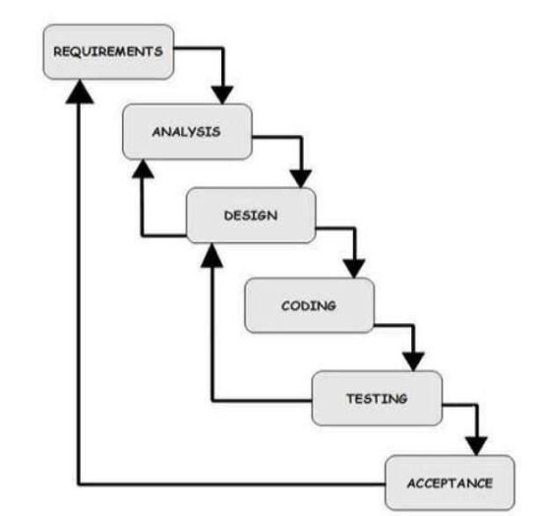

Figure 1

**3.4 Project Modules:**

* The project architecture comprises several interconnected modules, each playing a crucial role in the development and deployment of the real-time driver drowsiness and safety prediction system. At the frontend, HTML, CSS, and JavaScript are utilized to create a user-friendly web interface for interacting with the system. These technologies enable the design of a responsive dashboard where users can visualize real-time alerts, system status, and historical driving data. Through the web interface, drivers and fleet managers can access the system remotely, facilitating monitoring and intervention from any location.
* On the backend, Flask, a lightweight Python web framework, serves as the foundation for building the server-side components of the system. Flask facilitates the integration of deep learning models trained using TensorFlow, Keras, and PyTorch into the web application. These models, developed to detect signs of drowsiness, distraction, or unsafe driving behavior, analyze video streams captured by in-car cameras in real-time. Leveraging image detection models like YOLO-5, the system can accurately identify facial features, eye movements, and head poses indicative of drowsiness or distraction, enabling timely intervention to prevent accidents.
* Furthermore, the project utilizes datasets from Ultralytics GitHub libraries to train and evaluate the deep learning models effectively. These datasets, curated with diverse samples of driver behaviors and annotated with ground truth labels, serve as the cornerstone for model development and validation. By leveraging high-quality datasets, the system can generalize well to various driving scenarios and environmental conditions, enhancing its accuracy and reliability in real-world applications. Through the seamless integration of frontend technologies, backend frameworks, deep learning models, and datasets, the project aims to deliver a comprehensive solution for improving road safety through real-time driver monitoring and intervention.

**3.5 Diagrams**

1. Flow Chart:

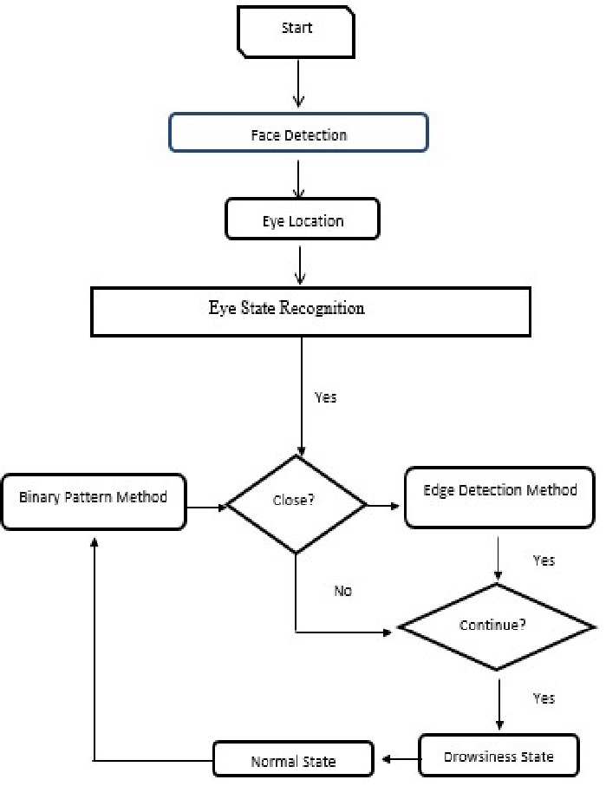

Figure: 2

1. Use Case Diagram:

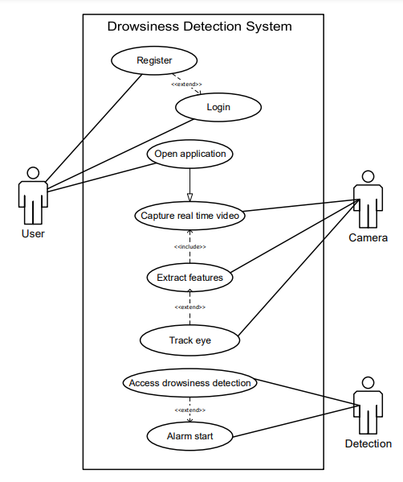

Figure 3

1. DFD:

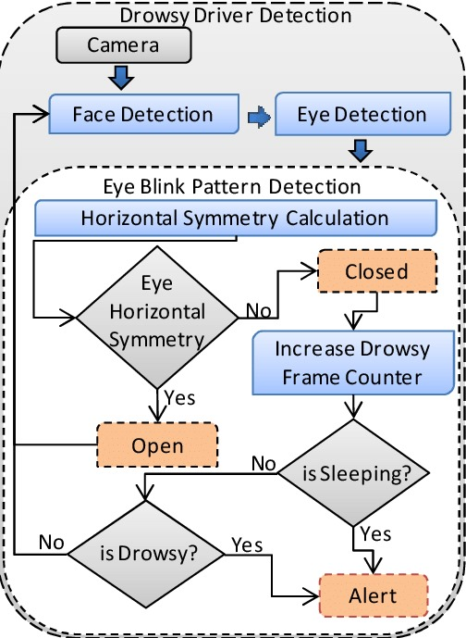

Figure: 4

**CHAPTER - 4**

**SYSTEM REQUIREMENTS**

**4.1 SOFTWARE REQUIREMENTS**

* **Frontend Web Application:**

|  |  |  |
| --- | --- | --- |
| **Sr No** | **Tech Stack** | **Tool Name** |
| 1 | Frame Work | Bootstrap CSS |
| 2 | Web Page | HTML, CSS and JAVASCRIPT |
| 3 | Audio Play | VLC Open-Source Library |
| 4 | IDE for development | Visual Studio Code |

Table no. 2

* **Deep Learning Model Development:**

|  |  |  |
| --- | --- | --- |
| **Sr No** | **Tech Stack** | **Tool Name** |
| 1 | Programming Language | Python |
| 2 | Deep Learning Libraries | TensorFlow, Keras, Pytorch |
| 3 | Video/Image processing libraries | YOLO-5, labelIMG |
| 4 | Training data | Ultralytics/yolo5 GitHub library |
| 5 | IDE for development | Visual Studio Code, Google Colab |

Table no. 3

* **Backend:**

|  |  |  |
| --- | --- | --- |
| **Sr No** | **Tech Stack** | **Tool Name** |
| 1 | Framework | Flask |
| 2 | Programming Language | Python |

Table no. 4

* **Version Control and Collaboration:**

|  |  |  |
| --- | --- | --- |
| **Sr No** | **Tech Stack** | **Tool Name** |
| 1 | Version Control System | Git |
| 2 | Collaboration platforms | GitHub |

Table no. 5

* **Documentation:**

|  |  |  |
| --- | --- | --- |
| **Sr No** | **Tech Stack** | **Tool Name** |
| 1 | Document Formation and Editing | MS Word, Adobe Acrobat |
| 2 | Images Design | MS Paint, Canva |

Table no. 6

**4.2 HARDWARE REQUIREMENTS**

* **Development Machine:**

|  |  |  |
| --- | --- | --- |
| **Sr No** | **Device** | **Specification** |
| 1 | Development Machine | * Processor: Intel Core i5 or AMD Ryzen 5 (or higher) * RAM: 4 GB or more * Storage: SSD with at least 128 GB * Graphics Card: NVIDIA GPU with CUDA support |
| 2 | Working Camera | Recording capability more than 10 pixels |
| 3 | Internet | Wi-Fi or Wired |

Table no. 7

**CHAPTER - 5**

**EXPECTED OUTCOME WITH GUI**

**5.1 EXPECTED OUTCOMES**

* Accurate Drowsiness Detection:
  + Develop a deep learning model capable of accurately detecting signs of driver drowsiness in real-time through analysis of facial expressions, eye movements, and other relevant features.
* Real-time Monitoring:
  + Establish a system capable of continuous and real-time monitoring of the driver, ensuring timely intervention when unsafe behaviors are detected.
* Timely Alarm Triggering:
  + Integrate an effective alarm system that promptly alerts the driver upon detecting signs of drowsiness or distraction, thereby preventing potential accidents.
* Reduced Accidents and Improved Safety:
  + 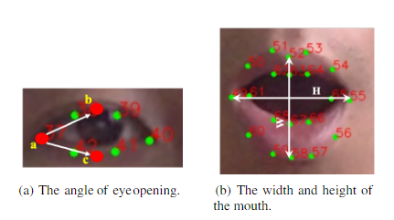Demonstrate a measurable reduction in accidents attributed to drowsy or distracted driving, thereby contributing to improved overall road safety.

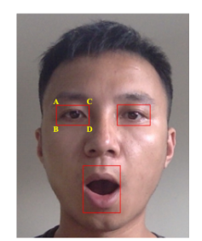

Figure: 6

Figure: 5

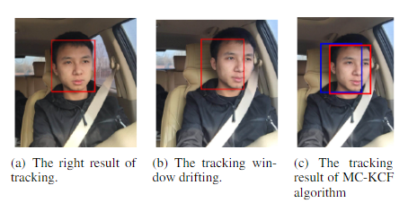

Figure: 7

**5.2 GRAPHICAL USER INTERFACE (GUI)**

* **Brief Overview of the Web Application UI:**

Our project's web application interface is designed with simplicity and functionality in mind, aimed at providing a straightforward and effective tool for monitoring driver drowsiness and safety. As the project is in its early stages, the current UI embodies a minimalist approach, ensuring users can navigate and utilize the available features without complexity.

* **Layout and Design:**

The web app's layout is intuitive, featuring a clean and organized design that prioritizes user experience. The main dashboard serves as the central hub where real-time monitoring information is displayed. This includes a live feed section showing the camera input and a notification area where alerts regarding drowsy driving indicators are prominently displayed. The design utilizes a neutral color palette to minimize distractions, with color-coded alerts to signify different levels of attention required.

* **Features and Functionality:**
  + **Real-Time Monitoring Display**: The core feature of the web app, this section shows a real-time video feed from the driver’s camera, with AI detections of drowsiness or unsafe driving behaviors highlighted.
  + **Alerts System**: When the system detects signs of drowsiness or other safety concerns, it generates audio alerts on the dashboard. These alerts are designed to be instantly recognizable, ensuring quick user response.
  + **Counter**: This counter counts the number of times you have been found drowsy to keep a record of the way you drive (driver’s driving nature).
  + **Reset Counter Button:** This button can be used when starting the vehicle again so that it will reset the previous count and store and count again from zero(0).
* **User Interaction:**

Interaction with the web app is kept deliberately simple. Users can start or stop the real-time monitoring with a single click. User can easily press the reset counter button to start the counter again from the start that is from zero (0).

* **Conclusion and Future Development:**

The current UI of our web application serves as a foundational step towards a more comprehensive and interactive tool for enhancing driver safety through drowsiness detection. As the project progresses, we plan to enrich the UI with more advanced features, including detailed analytics of driving patterns, integration with smartphone notifications, and personalized user profiles for a more tailored experience. Our goal is to evolve this basic web app into a robust platform that combines ease of use with powerful functionality to combat drowsy driving effectively.

* **Some Screenshots:**

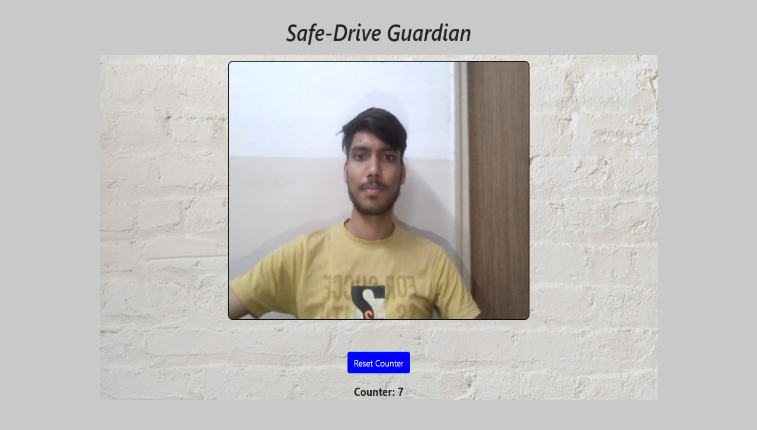

Figure: 8

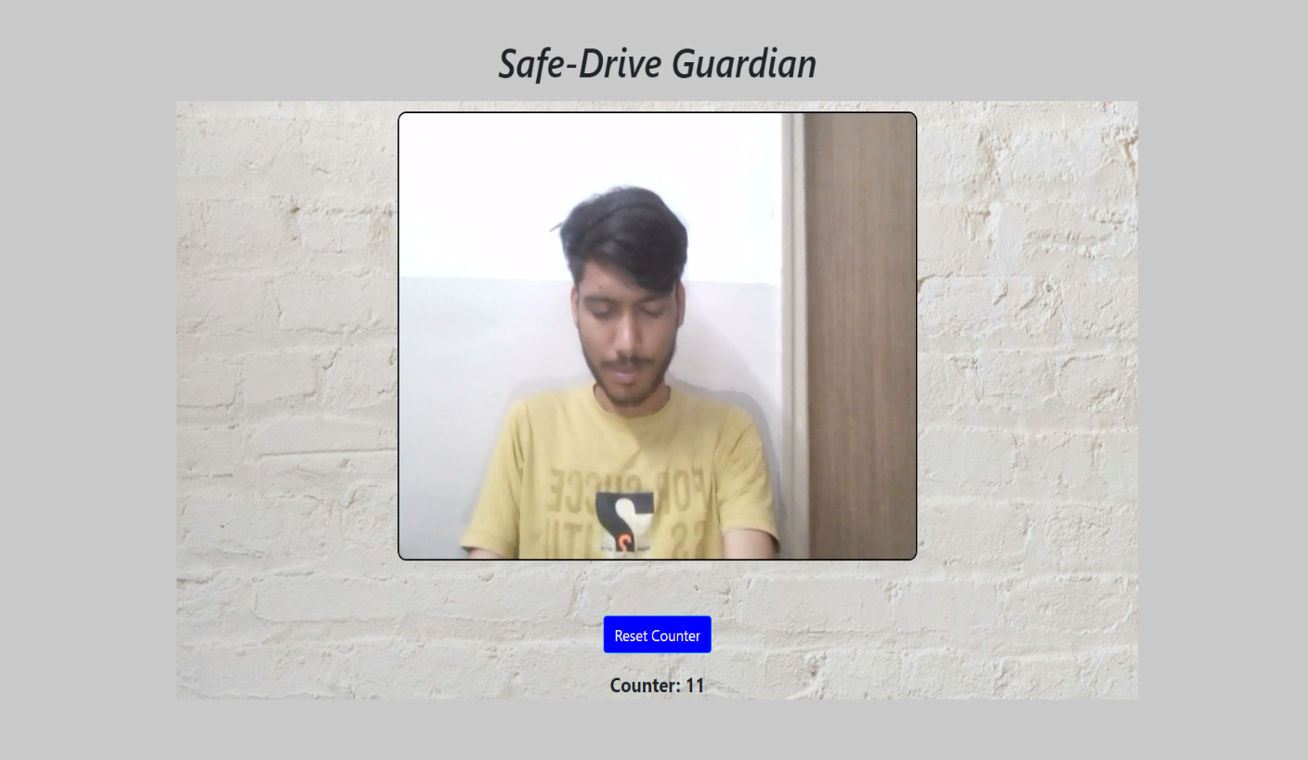

Figure: 9

**CHAPTER - 6**

**CONCLUSION AND FUTURE SCOPE**

**6.1 CONCLUSION :**

* In conclusion, our project on driver drowsiness and safety prediction represents a significant stride towards enhancing road safety through the application of deep learning technologies. By harnessing real-time inputs from a camera to detect signs of driver fatigue, drowsiness, and other unsafe behaviors like phone usage, this system stands as a beacon of preventative innovation in the realm of traffic safety. The successful implementation of this project not only underscores the potential of deep learning in transforming our approach to road safety but also sets a new benchmark for proactive accident prevention measures. The alarm system acts as an immediate corrective mechanism, potentially saving lives by alerting drowsy or distracted drivers before a mishap occurs.
* Looking forward, the implications of this project extend far beyond its current capabilities. As technology advances and more sophisticated models of detection and prediction are developed, the system's accuracy and reliability will only improve. This project lays the groundwork for future research and development in the field of automotive safety, opening doors to more integrated and intelligent systems capable of predicting and preventing a wider range of unsafe driving behaviors. Moreover, the scalability of this solution promises a future where road safety is significantly enhanced, contributing to the reduction of traffic-related fatalities and injuries on a global scale.

**6.2** **FUTURE SCOPE :**

1. **Integration with Vehicle Automation:** Integrating the drowsiness detection system with advanced driver-assistance systems (ADAS) and autonomous vehicles for improved safety interventions.
2. **Real-Time Health Monitoring:** Expanding the system to monitor vital health indicators of the driver, such as heart rate and blood pressure, to predict and prevent health-related driving impairments.
3. **Wearable Technology Compatibility:** Developing compatibility with wearable devices for continuous monitoring of driver alertness and overall health status.
4. **Enhanced Detection Algorithms:** Refining deep learning algorithms for more accurate detection of subtle signs of drowsiness and distraction, including microsleeps and cognitive distractions.
5. **Cross-Platform Integration:** Creating applications for smartphones and smartwatches that work seamlessly with the vehicle’s system, offering alerts and safety advice to drivers.
6. **Personalization and Learning:** Implementing machine learning techniques to personalize the system’s sensitivity based on individual driver profiles and behaviors over time.
7. **Expanded Behavioral Analysis:** Including the detection of additional risky behaviors, such as aggressive driving patterns and inconsistency in lane keeping, for a comprehensive safety system.
8. **Integration with Traffic Systems:** Linking the system with smart traffic management solutions to provide real-time data on driver behavior, contributing to wider efforts to improve road safety.
9. **Augmented Reality (AR) Support:** Employing AR for visual alerts on windshields, thus reducing the need for drivers to take their eyes off the road.
10. **Global Standardization and Regulation Compliance:** Working towards global standardization of driver drowsiness detection systems and compliance with international road safety regulations to facilitate widespread adoption.

In conclusion, the real-time drowsiness detection and safety implementation project stands as a testament to the power of technological innovation in addressing critical safety issues. As we move forward, it is imperative that such technologies continue to be refined, customized, and integrated into mainstream automotive safety systems, paving the way for safer roads and saving lives.

**CHAPTER - 7**

**REFERENCES**

* "Driver Fatigue Detection: A Survey" - Research paper:
  + <https://ieeexplore.ieee.org/document/7729629>
* "Driver Drowsiness Detection System Using Image Processing Techniques: A Review" - Research paper:
  + <https://www.sciencedirect.com/science/article/pii/S2212017317303342>
* "Real-Time Drowsiness Detection System for Drivers using Wireless Wearable EEG" - Research paper:
  + <https://www.ncbi.nlm.nih.gov/pmc/articles/PMC6154053/>
* "A Survey of Drowsy Driver Detection Systems" - Research paper:
  + <https://www.researchgate.net/publication/282078820_A_survey_of_drowsy_driver_detection_systems>
* "Driver Drowsiness Detection System using Machine Learning: A Review" - Research paper:
  + <https://ieeexplore.ieee.org/document/9049331>
* "Real-Time Driver Drowsiness Detection Based on Eye Tracking and Dynamic Template Matching" - Research paper:
  + <https://ieeexplore.ieee.org/document/8420801>
* "Drowsiness Detection System for Drivers using Smartphone-Based Sensors: A Review" - Research paper:
  + <https://www.sciencedirect.com/science/article/pii/S0960077919302109>
* "Real-Time Driver Drowsiness Detection System using Facial Feature Extraction and Machine Learning" - Research paper:
  + <https://ieeexplore.ieee.org/document/9137562>
* "Driver Drowsiness Detection System using Multi-level Fusion of EEG and EOG Signals" - Research paper:
  + <https://ieeexplore.ieee.org/document/7799075>
* "Real-Time Drowsiness Detection System using Infrared Thermal Imaging" - Research paper:
  + <https://www.sciencedirect.com/science/article/pii/S0957417420312884>
* "Driver Fatigue Detection System using Steering Wheel-Based Sensors: A Review" - Research paper:
  + <https://ieeexplore.ieee.org/document/8592158>
* "Drowsiness Detection and Alert System for Drivers using Smart Glasses" - Research paper:
  + <https://www.researchgate.net/publication/323211648_Drowsiness_Detection_and_Alert_System_for_Drivers_Using_Smart_Glasses>